“Shakespeare in Love “ September 2018

Our September Guild Program presents the familiar “Old English “ type-face and the modern variants based on this letter-form 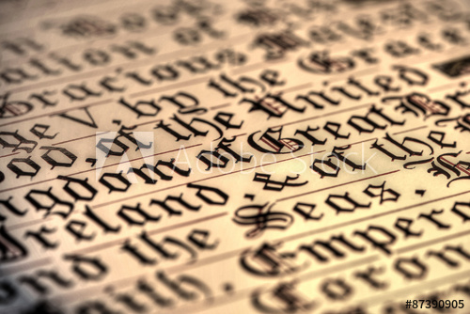 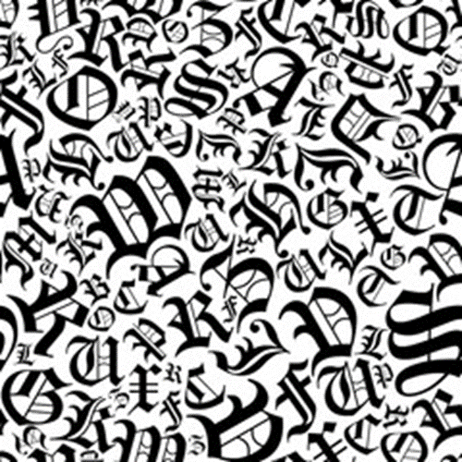

The 1400 to the1600’s Europe saw literature, both manually written or printed as expressions of learning and culture and for administration.
So, our Western letterforms evolved into more angular and narrow scripts thereby saving space in manuscripts made with expensive velum pages. “Old English” is similar to the other known scripts such as, “Textura, Gothic, Quadrata, and Blackletter”.
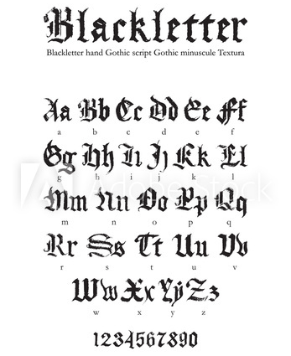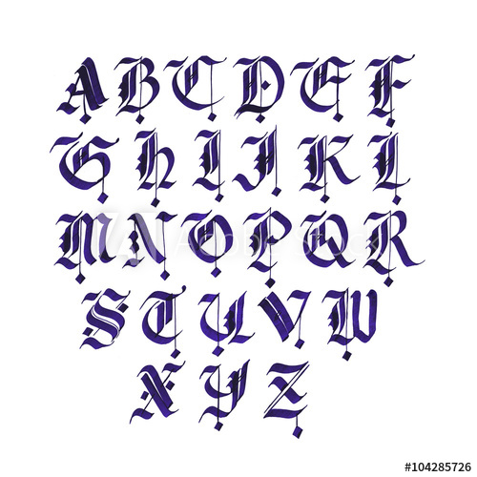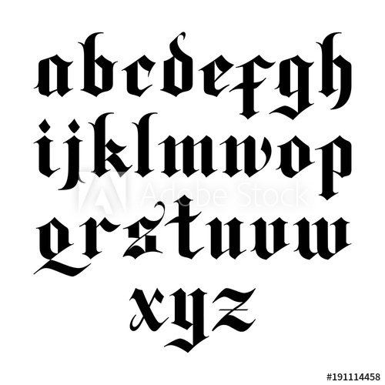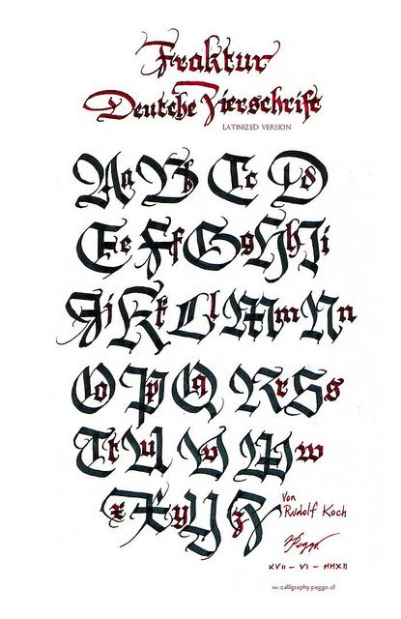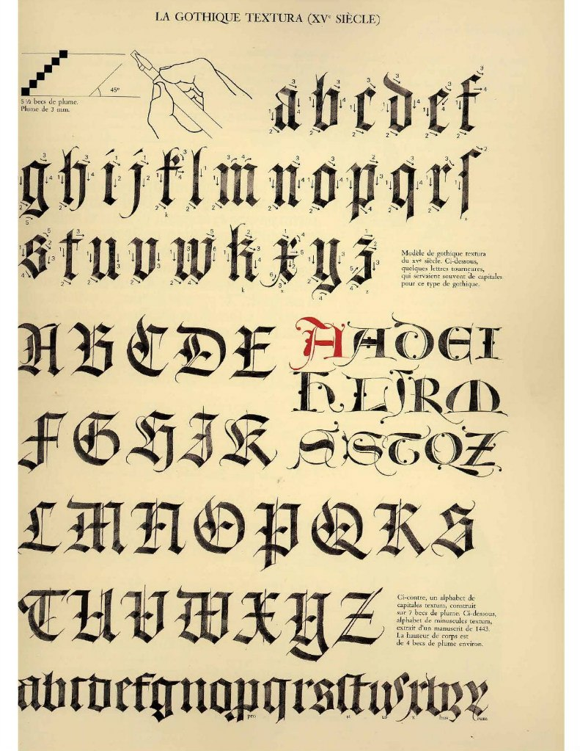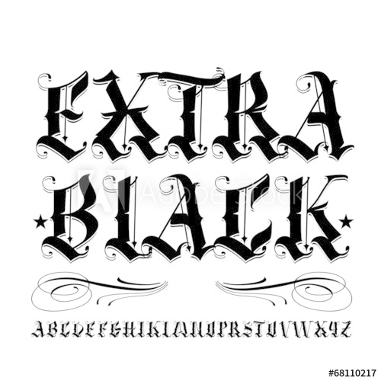
OnLine Websites to check out :
Medieval Manuscripts blog, Anglo-Saxon Treasures,
or the British Library manuscripts

Hope you are encouraged and inspired to practice your calligraphy with new variations on these “Old English “ scripts.

Tom Campos
VP Programs Chair

